Application
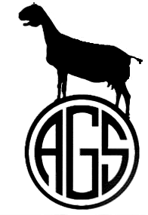
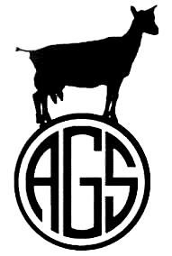

Group One-Day Test Permit

Under the rules of

Dairy Herd Improvement Association

and

The American Goat Society

American Goat Society
Kathy Winters, DHI Coordinator
12052 State Route E
Rolla, MO 65401
(573) 364-4207
kwinters@sprintmail.com

PROCEDURE FOR CONDUCTING A GROUP ONE-DAY MILK TEST

- Only AGS registered does are eligible for participating in a one day test.
- Start the procedure at least 30 days in advance.
- Hire a licensed milk test supervisor to conduct the test.
- Send this application to the DHI Coordinator, accompanied by the appropriate fee.
$25.00 (application received at least 30 days in advance) or
$50.00 (application received less than 30 days in advance)

This fee covers an unlimited amount of herds or animals tested.
- The DHI Coordinator will send you a permit, good for six months, along with the rules and regulations governing one-day tests. The test report will be included. Print out enough copies of the report for each herd owner and give them to each herd owner before the test occurs so he can enter information about his animals. A good way to handle this is to e-mail the report form to each owner so he can do the work by computer, print the report, and bring it to the test.
- Conduct the test at any time after you receive permission.
There shall be three milk-outs during a 24-hour period.
At each milk-out, the tattoos shall be read and checked against the registration papers.
Preliminary milk-out-Tester checks each doe after being milked to make sure udder is empty.
First and second official milk-out-Tester weighs, samples and records each doe’s milk.
During one of the milk-outs, miniature breeds must be measured by the tester in accordance with AGS DHI Rules and Procedures, and the measurement entered on the report form.
- Tester sends milk samples to lab, accompanied by the original report form.
- Tester sends one copy of the report form along with each owner’s doe data form to DHI Coordinator. The person in charge of test shall retain third copy.
- Test results shall be sent directly to the DHI Coordinator from the lab. DHI Coordinator will determine scores and will send the results to each herd owner along with applications for a star.

Detach and keep the above procedures for your records

APPLICATION FOR A GROUP ONE-DAY TEST PERMIT
(Please print or type)
Name of organization: _____________________________________________________Date of application: ____________

Name and address of lab: _______________________________________________________________________________

Name and address of tester: _____________________________________________________________________________

Name of authorized person: ___________________________ Signature of authorized person: ________________________

Address: __________________________________________________________________________________________

E-mail address: _________________________________________________ Tel. #: _____________________________
03/18

